Ranoa, Julius

CSC 121 001 Computer Science I

Homework. Part I – Review Questions.

Chapter 5. Page 311 – 312. Qn. 1 – 4, 14 – 16, 19 – 26.

1. To increment a value means to increase it by one.
2. To decrement a value means to decrease it by one.
3. When the increment or decrement operator is placed before the operand (or to the operand’s left), the operator is being used in prefix mode.
4. When the increment or decrement operator is placed after the operand (or to the operand’s right), the operator is being used in postfix mode.
5. The for loop is ideal for situations that require a counter.
6. The do-while loop always iterates at least once.
7. The while and for loops will not iterate at all if their test expressions are false to start with.
8. The break statement causes a loop to terminate immediately.
9. The continue statement causes a loop to skip the remaining statements in the current iteration.
10. What header file do you need to include in a program that performs file operations? fstream
11. What data type do you use when you want to create a file stream object that can write data to a file? ofstream
12. What happens if you open an output file and the file already exists? The existing file will be erased and new file will be created.
13. What data type do you use when you want to create a file stream object that can read data from a file? ifstream

Homework. Part II – Programming Challenge.

Chapter 5. Page 321. Qn. 26 – Using Files – Total and Average Rainfall

Files: main.cpp

RainfallReader.h

RainfallReader.cpp

Rainfall.txt

Screenshot of Runtime:

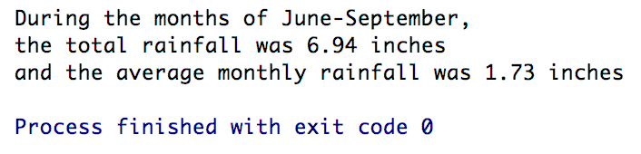

Source Files:

**main.cpp**



**Header File: RainfallReader.h**



**Implementation File: RainfallReader.cpp**





**Data File: Rainfall.txt**

